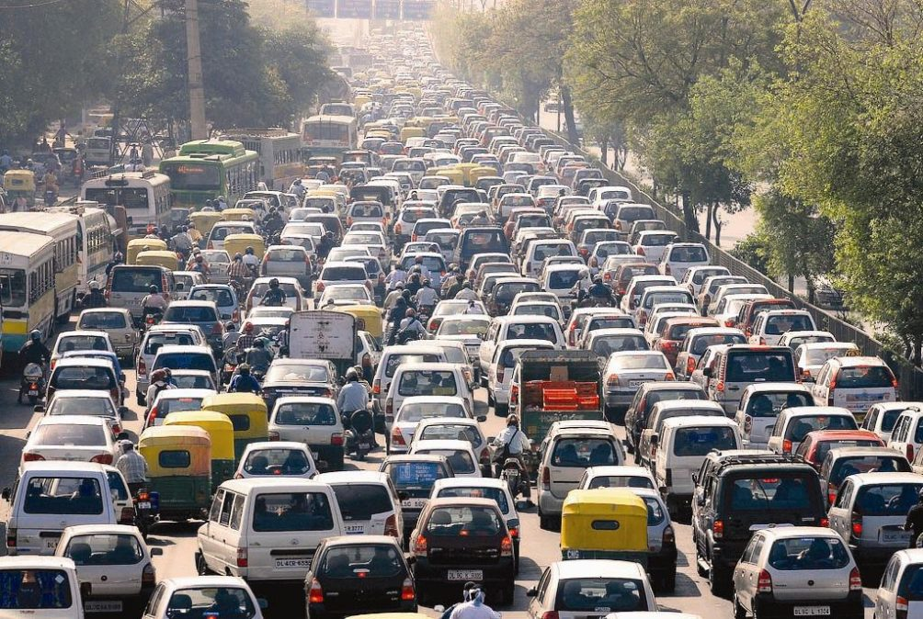

|  |
| --- |
| Design the AI based route optimization technique to improve GPS functionality: |
|  |
| July 29  Authored by: Piyush Srivastava |

# INTRODUCTION

GPS navigation systems use stored map information for determining optimal route selection based on a shortest path algorithm. This technique is quite successful in getting you to where you want to go in a reasonable time and is fault tolerant in the sense that it can automatically reroute in case of error. One disadvantage of this approach is that it does not have any memory. It does not automatically remember the actual time it took you to get there nor does it learn from that experience and use the actual measurements to improve future route selection. A simple method for modifying a GPS navigational system to incorporate a simple learning paradigm using velocity profiles is described. In addition to learning, these velocity profiles can also be used to extract features from the environment which can then be used to further improve the accuracy of optimal route selection. It is assumed to be completely autonomous which means that it requires no user input or intervention. All of the required information is derived from recording GPS location, date and time.

ABOUT GPS:

GPS is a tool used to locate objects in real positions as well as their time. It is used for tracking, scientific uses, surveillance as well as management in various sectors. It is used in all weather conditions. Like other applications, traffic management systems require accurate and real-time data that GPS offers. GPS in traffic management is used as a data collecting tool which shows the speed and spatial coordinates of cars at certain times.

# Algorithm Used:

For Traffic Analyzing:

We have used open-cv to analyze the traffic with the help of yolo algorithm (You Only Look Once — is an extremely fast multi object detection algorithm which uses convolutional neural network (CNN) to detect and identify object)

For finding shortest route:

We have used Q-Learning Algorithm to find the shortest route.

For extracting data relating to traffic and other detail:

We have used local SQL database

# Help Taken From:

Important Websites:

1) <https://grindgis.com/gps/application-of-gps-in-traffic-management-systems>

2) <https://journals.sagepub.com/doi/full/10.1177/1550147716683612>

3) <https://pysource.com/2019/06/27/yolo-object-detection-using-opencv-with-python/>

4) <https://www.geeksforgeeks.org/>

5) <https://www.tutorialspoint.com/>

6) <https://colab.research.google.com/drive/1E2RViy7xmor0mhqskZV14_NUj2jMpJz3#scrollTo=fKun8LInsas9>

7) <https://www.youtube.com/watch?v=iKdlKYG78j4>

8) <https://github.com/pragatibaheti/Automated-Optimal-Path-Finder/blob/master/code.ipynb>

9) <https://heartbeat.fritz.ai/automating-an-ai-to-find-the-shortest-route-using-reinforcement-learning-19dc9a3c0411>

Research paper Read:

1) IEEE TRANSACTIONS ON INTELLIGENT TRANSPORTATION SYSTEMS, VOL. 5, NO. 2, JUNE 2004

VIRTUOUS: Vision-Based Road Transportation for Unmanned Operation on Urban-Like Scenarios

2) Special Section: Scientific Seminar of the Italian Association of Transport Academicians (SIDT) 2019

Traffic management system for smart road networks reserved for self-driving cars

3) 2010 2nd International Conference on Software Technology and Engineering(ICSTE)

Artificial Intelligence in GPS Navigation Systems

4) Artificial Intelligence in GPS Navigation Systems Intelligence transportation system -2003

5) International Journal of Scientific & Engineering Research, Volume 7, Issue 11, November-2016 ISSN 2229-

5518 ROUTE OPTIMIZATION TECHNIQUES: AN OVERVIEW

Code Link:

<https://github.com/PiyushSrivastava28/Projects/tree/main/Routing%20Optimization%20Using%20AI>

Result:

Able to the shortest time-consuming route between source and destination by analyzing the traffic on each route.